Thoracic Spine and Shoulder Mobility Exercises

*Poor posture leads to tight shoulders and weak scapular stabilizers. Spending most of the day in a seated position will cause poor posture. The following exercises will help improve overall shoulder mobility and therefore enhance scapular stability. Improving mobility and stability through the entire shoulder girdle is a key component for all athletes. By doing so, an athlete will be able to place their shoulder complex in an optimal position to maximize strength and power in a quality manner. Engaging in upper body strength exercises, with immobile shoulders and weak scapular stabilizers will lead to potential injuries and poor performance.

Foam Rolling and Warm-up:

Before performing the following the stretches one should perform 3-5 min. of light cardio work followed by a few foam rolling exercises

T-Spine Foam Roll

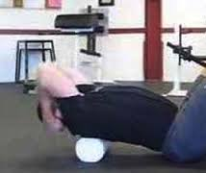

Lay on top of a foam roller with your knees bent and heels on the floor. Place hands behind head and bring elbows together. Slowly roll up and down on roller using your legs to push yourself up and down on roller. Push your spine into the roller. Continue for 60 sec.

Lat Roll
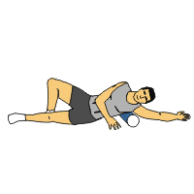

Place foam roller below the arm-pit area on your lat muscle. Keeping your palm facing up, slowly roll the roller 4-6 inches back and forth in this area. Continue for 60 sec. each arm.

*Stretching and Mobility Work

Side lying sleeper stretch

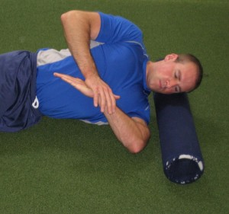

You can use a foam roller or rolled up towel to support your head. Align your shoulders as vertical as possible. Bend bottom arm elbow to 90 degrees. While squeezing your shoulder blades together, to create stability in the upper back, gently push down on wrist (not fingers or hand) until you feel a mild stretch in the back/top portion of your shoulder. Hold for a minimal of 20 sec. and repeat 2x.
Lat Stretch

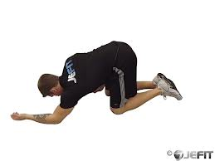

Reach out above your opposite shoulder in a diagonal position and place your other hand on top of the bottom hand. Keep the elbow straight and lean your shoulder back in the opposite direction. You should feel the stretch just below your arm pit area near your rib cage. . Hold for a minimal of 20 sec. and repeat 2x.

Side Lying T-Spine Arm Slides

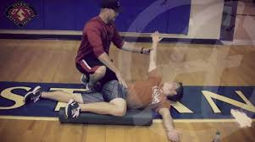

Bring Top Leg over and extend top hand to reach behind you and towards the floor. Try and keep the forearm, elbow, wrist and fingers in constant contact with the floor as you slowly slide the arm up towards your head and then slowly back down towards your hips. Turn the thumb up as you slide up and turn it down and you slide down. Adjust your top leg so you can allow the sliding arm to be flush on the floor. Hold your knee down of the top leg with the opposite hand. Attempt 6-8 slides ea.

Side Lying T-Spine Arm Reach

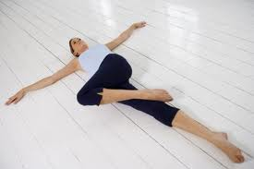

Position is same as above. Just extend and reach with the top arm and hold for couple of seconds. Arm should extend so the hand is above the shoulder and elbow is fully extended. Repeat 6-8 x and then switch to the other side

3 point position - T-Spine Rotations

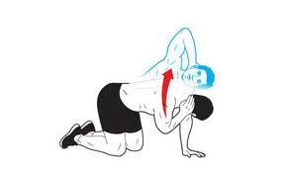

Keep back straight and hips over knees. Slowly rotate and lift elbow towards the ceiling keeping your low back stable. Hold the top and bottom portions of the movement for a 2 count. Complete 8-10 reps on each side.

Floor Angels Exercise

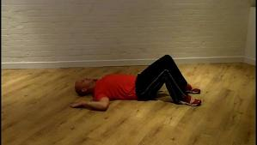

Bend knees toward chest and cross ankles. Keeping your low back flush against the floor, slowly raise your hands above your head keeping the arm as flush as possible against the floor. Repeat slowly – 8-10 reps x 2 sets.

